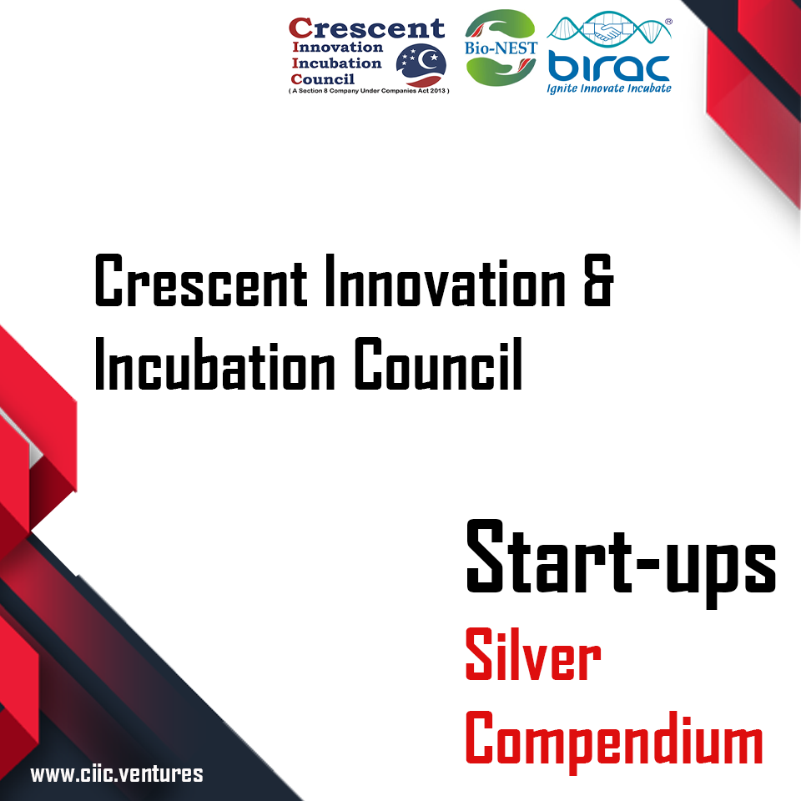

COMPENDIUM

|  |  |
| --- | --- |
|  |  |
|
| S. No | Start-up Companies |
| 1 | Wegot Utility Solutions Pvt Ltd |
| 2 | Kankyo Cleantech (India) Pvt Ltd |
| 3 | Farmagain Agro Pvt Ltd |
| 4 | Rekindle Automations Pvt Ltd |
| 5 | Aindra Labs Pvt Ltd |
| 6 | Onium Life Sciences Pvt Ltd |
| 7 | Agrit Green House Solutions Pvt Ltd |
| 8 | Ravikas |
| 9 | Greenflora Biosciences Pvt Ltd |
| 10 | SCADA Geoinformatics Pvt. Ltd |
| 11 | Kardle Industries Pvt Ltd |
| 12 | Frutunes Food Products Pvt Ltd |
| 13 | Meiyur Education and Skill Development Pvt Ltd |
| 14 | Precise 3D Metrology and Design Solutions Pvt Ltd |
| 15 | MADIEE Games Pvt Ltd |
| 16 | Precilabz Techno Private Ltd |
| 17 | Bigphi Technologies Pvt Ltd |
| 18 | Jothna Software Solutions Pvt Ltd |
| 19 | XSDATA Factory Pvt Ltd |
| 20 | Mirrar Innovation Technologies Pvt Ltd |
| 21 | Sirpi Software Pvt.Ltd |
| 22 | ACRE-Alliance For Critical Regionalism Pvt Ltd |
| 23 | Hi fusion Enerygy |
| 24 | Patent ProActive Labs |
| 25 | Dhanvantri biomedical Pvt ltd |
| 26 | Sabari biomedical |
| 27 | Impendus Electronics |
| 28 | Propeller Technologies research & Developement |
| 29 | Sirius motorsports india pvt limited |
| 30 | Medmorph 3d |
| 31 | The car guy |





Crescent Innovation & Incubation Council (CIIC) has been established as a Section-8 not for profit company and registered under Indian Companies Act 2013. CIIC acts as a “One Stop Shop – Technology Business Incubator (TBI)” for Start-ups. CIIC facilitates entrepreneurial & innovative ecosystem to all the stakeholders including the students, faculty, industry, investors and society at large. CIIC is under the ambit of B S Abdur Rahman Crescent Institute of Science & Technology which is deemed to be university under section 3 of UGC Act 1956. CIIC is presently focusing on the disruptive technologies in the domains of Industry 4.0, Mobility Transportation & Life Sciences. CIIC has setup 25,000 sqft state-of-art facility for start-ups with eight Centre of Excellence

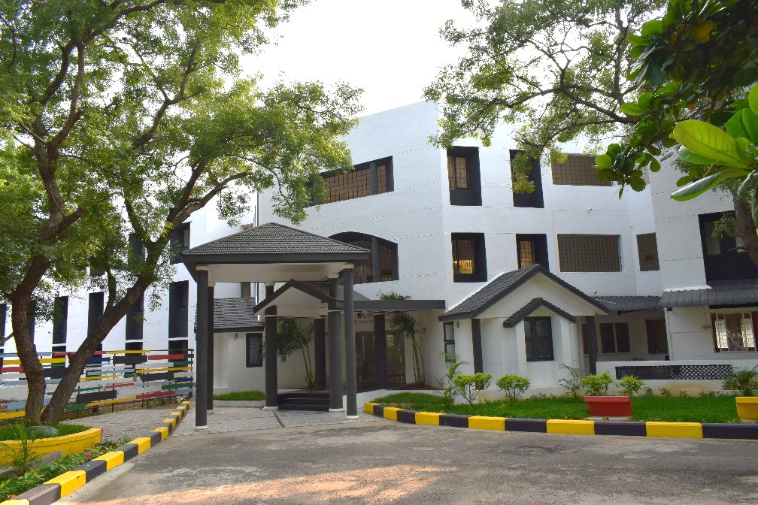

**Highlights of CIIC**

**Alumni Entrepreneurs Network**

**25,000 sqft Space**

**Eminent Advisory Board**

**Access to Seed Funding**

**Industry Connect**

**Incubation Network**

**Investors Connect**

**Mentors**

Thrust Areas

Mobility & Transportation

Life Sciences

Industry 4.0



Partners

